“But it’s always been done this way.”
– Baseball’s training mentality
COACHHELKE@YAHOO.COM
Why Most Players are Just Learning How to Swing and Not Learning How to Hit
©2020 The Baseball Observer & 360 Peak Performance

Why most players are just learning how to swing and not learning how to hit
by Coach Helke
I’ve been asked many times why I really don’t ever train using a batting tee (or soft toss for that matter) any more. While this article might seem like an overkill response, when you consider the wide acceptance and all the reasons given that seem “logically functional” for training with a batting tee, it’s necessary to provide facts and evidence based on scientific proof, research and real life results why it really isn’t functional. Including footage of batting tee swings vs. live pitching swings.

Now in all fairness, I will admit I still use the batting tee on rare occasions. It does have a very limited purpose. I do think the batting tee can be a quick building block for the athlete who is extremely unaware of the motor skill they’re trying to learn. It can also be useful in helping an athlete initiate kinesthetic (feel) awareness. But only for 8-10 swings, then put the batting tee away and please don’t use it every day - if at all after that. Even with young players, it’s best not to use a batting tee if you can help it.

The problem is, most athletes and coaches focus and rely entirely too much on the batting tee. They treat it
1
as the “Holy Grail” for hitting. While it’s true proper swing mechanics are vital to the development of good hitters, it doesn’t automatically mean he or she can hit. There is much more to hitting than what the swing is "supposed" to look like.

What a coach sees a hitter doing off a tee won’t help identify or correct weaknesses nor encourage strengths. Live action is much more helpful in identifying issues with mechanics, timing, perception and correcting them. Searching for the “perfect” swing should not be the goal. What’s perfect for one type of pitch isn’t perfect for another.

I’ll start you off with a little tease. What most coaches and trainers never tell players or parents (if the coach knows this) is that batters actually make an educated guess of where they believe the ball will cross the plate. A batter cannot see the entire path of a pitched ball. The best players in the MLB lose sight of the ball 8-15 feet before the plate. Even if they could see the ball all the way, once the ball is about half way to the plate humans visual-motor system isn’t quick enough to make any
adjustments. That’s why players have to
as the “Holy Grail” for hitting. While it’s true proper swing mechanics are vital to

the development of good hitters, it doesn’t automatically mean he or she can hit. There is much more to hitting than what the swing is "supposed" to look like.

What a coach sees a hitter doing off a tee won’t help identify or correct weaknesses nor encourage strengths. Live action is much more helpful in identifying issues with mechanics, timing, perception and correcting them. Searching for the “perfect” swing should not be the goal. What’s perfect for one type of pitch isn’t perfect for another.

I’ll start you off with a little tease. What most coaches and trainers never tell players or parents (if the coach knows this) is that batters actually make an educated guess of where they believe the ball will cross the plate. A batter cannot see the entire path of a pitched ball. The best players in the MLB lose sight of the ball 8-15 feet before the plate. Even if they could see the ball all the way, once the ball is about half way to the plate humans visual-motor system isn’t quick enough to make any
adjustments. Therefore, players have to decide (yes, guess) what to do and where to swing before the ball gets approximately half way to the plate. Hitting is based on early identification
guess (an educated guess) what to do and where to swing before the ball gets approximately half way to the plate. Hitting is based on early identification and assessment of the many variables of a ball being pitched simultaneously with the batter’s body movements. (these statements are covered more in depth later in this article).

Consider this question:

When a golfer practices, does his coach roll balls to him to hit?

Of course not. A golfer never hits a moving ball so he doesn’t practice or train hitting a moving ball. So why in baseball do we believe we have to train swinging at stationary ball when in a game we only swing at a moving ball?

While occasionally this article is a bit academic in approach, it is easy to read and understandable. Only a sample of the immense research and real-life examples will be referenced. Not every aspect is covered because it would be much longer than it already is!

and assessment of the many variables of a ball being pitched. (these statements are covered more in depth later in this article).

It’s the ability to identify and adjust early to a type of moving pitch that’s important.

I want to start you off with a question:

When a golfer practices, does his coach roll balls to him to hit?

Of course not. A golfer never hits a moving ball so he doesn’t practice or

In a scene from the 1999 film The Matrix, Morpheus gives Neo an option:

"You take the blue pill, the story ends. You wake up in your bed
and believe whatever you want to believe.”

“You take the red pill, you stay in Wonderland, and I show you
how deep the rabbit hole goes."

Which One Will You Take??

2
train hitting a moving ball. So why in
The material provided within the following pages challenges the use of probably the most widely implemented and accepted baseball training aid in baseball history. The batting tee.

Be prepared. This article will test some of your deepest held beliefs about training with a batting tee of any type.

We all have the best intentions when it comes to our athletes. We know that for athletes to perform correctly and at their potential best they have to be exposed to the correct knowledge, tools and training. This means that a coach, trainer or parent needs to take the time to learn, understand and update what they are teaching on a regular basis. But do we as athletes, coaches, trainers and parents always practice this?

Every day question what you think you know. Many times, being exposed to just one new idea reveals there are more things to learn.
Let’s begin…
baseball do we believe we have to train swinging at stationary ball when in a game we only swing at a moving ball?

While this report is a bit academic in approach, it is easy to read and understandable. Only a sample of the immense research and real-life examples will be referenced. Not every aspect is covered. The material provided challenges the traditional learning and training methods for hitting used by most athletes, coaches, trainers and parents regarding the batting tee.
Be prepared. This article will test some of your deepest held beliefs about training with a batting tee of any type.
It’s the ability to identify and adjust early to a type of moving pitch that’s important.

Section One - Intro

Why baseball believes in the batting tee – “It’s always been done that way”
Most tout a handful or possibly twenty or thirty successful players, past or present, who use or have used a batting tee as proof that a batting tee is the single-best practice element for a hitter. Yet what isn’t stated is the fact that over the years there have been tens of thousands that have also used a batting tee that weren’t successful. Why does that fact tend to be omitted? Why bring this up at the beginning?
You have to be aware and have a brief understanding of just a couple things that influence human beliefs before we can continue. The reason why you yourself might be feeling some resistance to this article already.

The Illusion of Truth Phenomenon
Years of scientific research has shown that the more someone hears, reads, sees or speaks any statement regularly, the more they believe it to be true or valid. It makes no difference whether the information is true or false. The only thing that matters is how often they’re exposed to it. Especially if whoever is presenting the information seems very knowledgeable. If most do something a certain way, it’s likely to be
the viewed as best way. It’s the status quo. The status quo is extremely pervasive. People don’t even realize that
3

there are other ways of doing things because the status quo is all they’ve ever done and followed. Unfortunately,
a lot of baseball training for hitting is based on the Illusion of Truth.

Confirmation bias
Confirmation bias simply put is the tendency people have to embrace information that supports their beliefs and reject information that contradicts them. This is one of the most researched psychological phenomena.

Emotions
People tend to make decisions based on emotions not facts. Research has shown time and time again that emotions trump fact almost every time. Emotions are the core of our motivations. Why do you think we tell children and even adults to count to 10 before reacting? Just Google “Why facts don't change our minds”. Your emotions directly influence your attention, meaning and memory (1,2,3). If you don’t think the batting tee is an emotional subject, just keep reading…

After years and hundreds of subsequent experiments the scientific evidence has confirmed and elaborated that even when someone’s beliefs have been totally refuted or even just partially refuted, the majority of people will still fail to make appropriate revisions in those beliefs.

Like Lemmings jumping off a cliff, they just keep following the others right over the edge.

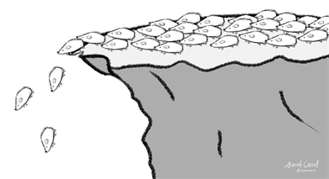

My point? Please “Don’t be a Lemming” if you want to reach your full potential. But to do that, you have to have a Growth Mindset (open).
“Facts do not cease to exist because they are ignored.”
-Aldous Huxley

Growth Mindset
Dr. Carol Dweck, a widely accepted expert in personality psychology, identifies two types of mind sets. A Growth mindset (open) and a Fixed Mindset (closed).

Growth mindset people believe they can always learn more, do more and get better. They are confident and work hard to expand their potential and knowledge.

Fixed mindset people on the other hand, only look at information that supports their views. They easily distort information that supports their beliefs and usually discount information that challenges or even disproves their beliefs.

It goes without saying that any good athlete, coach, trainer or parent has a growth mindset. They know to truly grow and advance they need to be stretched and to stretch others. They are actively searching and open to taking in a full range of information and knowledge.
4

They get out of their comfort zone and challenge what they currently think they know or believe. They search for factual proof, supporting research, hard facts and evidence to challenge their current beliefs to guide them. Even if what they learn will potentially change their personal beliefs or if a coach, how they train others.

Pride, ego and emotion are set aside
This is who the article is for. The ones who demand cold hard facts based on actual scientific research and practical proof. They want truths - not theory, not how “functional” something might seem or assumptions. It is also backed up with real life experience and visual support.

So, if you believe you are one of those good athletes, good coaches, good trainers or good parents that has an open mindset and want the best for themselves and their athlete(s), then please keep reading.

For the skeptical rest, I respect we all have opinions. All I ask is that you read this entire scientifically researched backed report with a growth mindset before coming to any conclusions. It’s up to you to decide what to think after you have thought about it carefully and have considered all the relevant facts and real life evidence.

This article isn’t trying to persuade or convince anyone to change their mind. It’s not trying to manipulate you. No, this article presents knowledge – Facts vs. Myths. I agree it’s not all about the science. It’s about what you do with it.

I’ll end this section with this:
“Living in an information age, it is easy for people to become insensitive to the important distinction between information and knowledge. The most important difference is that information has a much higher chance of being incorrect than knowledge. Information is merely access to opinions or data, with no implied degree of accuracy. Information is also much easier to access in the age of the Internet and wireless communications. Do not confuse ease of access with accuracy or value. This distinction is clearer as you look at the hierarchy of the kinds of sources used for scholarly research and a simple strategy for the evaluation of the quality of a source.

The key element of all science: evidence. Science is based on logical analysis and the balance of many controlled studies.”

(excerpt from: Knudson, Duane. Fundamentals of Biomechanics 2nd Edition. 2007 Springer Science + Business Media, LLC)

This article uses scientific evidence, research, scholarly journals, years of real life experiences and real life examples as evidence.
5

Arguments for Training Using A Batting Tee
Section Two
Following is just a sample of actual reasons stated by many coaches and copied on thousands of baseball hitting web sites, training sites, blogs, YouTube, etc. that try to convince the athlete, coach or parent that the batting tee is good tool…the best tool to use. Every point is covered in this report.

6

Listen to what most say about using a batting tee. They are using assumptions, philosophies, what seems logically functional, what’s easy, predictable, what seems to be practical or functional, their personal beliefs or practices. They are thoughts and ideas with very limited or actual scientific backing.

This isn’t a slam on anyone. Most coaches and parents truly want to help their athletes and have good intentions. It’s just they don’t have all the information. While an athlete might make some strides training using a batting tee, the facts show it dreadfully slows their development and for many, actually keeps the athlete from advancing to their full potential.

Granted, players can do a lot of drills with a tee. That’s what a tee is made for, to do drills. A batting tee is predictable, easy and will make a player feel good because they can hit the ball every time. But athletes play a game they don’t “drill” a game.
FACT: The pitch a batter swings at has everything to do with
how well they hit.

In a game, the ball never just sits right there for a player to hit. The batter never knows where the next pitch will be, at what trajectory or speed. There’s not just one type of pitch being thrown to a specific spot or location. A game isn’t easy. It’s ugly, tough, demanding and unpredictable. With many different types of pitches (both from RHP and LHP and arm angles) and many different locations. There are many different swing types needed. The fact is, the pitch a batter swings at has everything to do with how well they hit.
7

A batter can have the “perfect swing” but if they don’t take into consideration environmental variables, swing at bad pitches or their timing is off, they will not be successful.

Athletes can learn perfect hitting form and use a batting tee all day, but that won't prepare them for a real game. A batter has to learn to assess environmental factors/ variables such as the movement, speed and trajectory of the ball which change pitch-to-pitch. A batter has to be able to assess all variables to make solid contact. This also includes the characteristics and variability of different pitchers’ movements and release points. Context of the situation also influences a batter’s swing.

It is impossible to swing a bat exactly the same way when we take into account the environmental variables on

the task goal (e.g. swinging a bat to hit a moving ball). Plus, physiologically muscles and joints do not always work in the exact same way even for the same action. You will soon see that practicing to swing a bat to hit a ball off a batting tee to replicate the same movement in exactly the same way through repetitive drills does not simulate the context of the real performance environment.
8
Location alone doesn't determine the type of pitch nor the type of swing needed

We can all agree the pitch a batter swings at has everything to do with how well they hit. So, the type of swing is actually dictated by the response to a type of pitch.

Before the pitcher throws a ball, here are just a few basic things the batter doesn’t know:
1. Pitchers movement and ball release point.
2. Where the ball will actually cross the plate.
- High, middle, low. Inside or outside or if it even crosses the plate.
3. At what possible speed will the ball arrive which affects a batters timing and
initiation (fast ball, curve ball, change-up, etc.).
4. At what angle/ trajectory will the ball come in at (fast ball, curve ball,
change-up, etc.).
5. Whether they are going to swing or not to swing. There are many studies
that show muscle tension is different when anticipating what action to take
vs. already knowing what action to take. (Live pitching vs. batting tee).

From little league all the way into the professional ranks, players are being taught how to swing a bat, not how to hit. The main culprit for this is the batting tee. Soft toss is the second reason. While an athlete might make some strides training using a batting tee, it dreadfully slows their development, keeps the athlete from advancing to their full potential and doesn’t support long term learning retention. Despite how "functional" it may seem, batting tees do the complete opposite.
“Hitters spend countless hours working on their swing mechanics. The majority of their time training is with tee drills and soft toss.
Yet, as coaches, we constantly see the same hitters repeat the same mistakes: opening up too quick in the swing, continuing to roll their wrists and pull ground balls on the outside pitch, not “loading” on time or swinging at pitches out of the strike zone or in the dirt, going into slumps, etc.” (4)
Despite how "functional" it may seem, batting tees do the complete opposite
Section Three

9
The act of hitting a live pitched baseball is:
- A Dynamic Interceptive Motor Skill. By definition: involves the ability to synchronize one’s own movement to that of a moving target. To be successful, an individual must pick up and use perceptual information about the moving target. It requires the individual to link their own movement and the spatial and temporal constraints being imposed by the moving target. The ball is being thrown by a pitcher who is trying to manipulate the balls flight, so the batter must use perceptual feedback, mainly from their vision, to tell him/ her where they believe the ball is while it is in motion and then must time the swing correctly in relation to this assessment. Coordination of dynamic interceptive movements are predicated on the cyclical relations between an individual’s actions and information sources from the performance environment (5).
- An Open Skilled Sport. By definition, open skilled sports are when an athlete has to coordinate his/ her actions in accordance with the movements of an object to be acted upon or those of a partner or opponent. There is variability in timing and in the direction, length and height of the ball trajectory (6). It’s learning movements to an unstable, ever-changing environment where the emphasis is on the athlete’s capabilities to select the appropriate response in a given situation for success.
- A Complex Interactive skill. This refers to the general ability to interact with the external world to accomplish a task. A typical interactive task requires the person to look for relevant information and choose the right actions. The uncertainty of the outcome of an action increases when the mapping between recognizable cues and actions becomes more complex and when there is interdependency between actions and outcomes.
- Externally paced skill. The environment, which includes opponents, controls the rate of performing the skill. The performer must pay attention to external events in order to control his/her rate of movement. These skills involve reaction and are usually open skills. i.e. in ball games, the performer must time his actions with the actions of other players and the ball (7). This also means there is a time constraint/ time pressure. The athlete must take action within a very limited amount of time. So, a very limited time to assess, decide and act.
- Variable skill task. The skill is applied to a number of different environments/ conditions/ stimuli, allowing both the development of the skill and the ability to adapt the skill to a range of possible situations. This is vital for open and interactive skills (7).
- Choice Response Time Task (Hick’s Law). The more stimuli or more responses choices there are, the slower you get. In hitting, response times reflect the time it takes to interpret several different stimuli, get information from memory, initiate a muscle response and to act or not to act.
…just to name a few

10

You see, in real life, the batters swing type is actually dictated by quickly identifying and assessing several external variables before delivery and of an approaching ball. Here are just a few of those things:

- Pitchers movements and ball release point and arm angle. Plus the situation.
- Estimated ball speed and predict where it will cross the plate. Research (8,9,10) has shown that a batter cannot see the bat hit the ball because of the limitations of human visual-motor control. They estimate or guess where it will be (contrary to the statements that some athletes said they could). This is because of angular velocity and other biological limitations. So early pitch variability is paramount to identifying environmental variables outside the control of the batter which influences the swing.
- Location - the general direction the ball is moving. High, low, inside or outside, etc. Possible Break - possible shifts in direction (two seam fast ball, four seam fast ball, curve, change-up, etc.). All effect the ball path/ trajectory to the plate which affects the angle of the bat path and timing to hit the ball as solid as possible.
- Deciding whether to swing or not. That means they have to assess the variables early and decide whether to swing or not. This has to be done by the time the ball is half way to the plate.

Athletes have to anticipate action outcomes based on events presented earlier in a movement sequence that must be performed under severe time constraints.

Yet when working off a batting tee, even before the batter initiates his swing, they already know all five basic criteria stated previously that’s unknown versus live pitching:
- No pitcher, so no pitcher movement or ball release point. No situation. No pressure.
- Where the pitch is exactly located.
- What speed (0 mph since it’s on the batting tee thus giving him/ her all the time in the world (no time constraint) to physically and mentally prepare for it. Will see the bat and ball contact.
- Already presupposes/ assumes a single approach angle/ trajectory of the ball. Because of this, almost every swing practiced off a batting tee in each tee position, one swing pattern is used. The batters “preferred” swing pattern.
- They know they are going to swing (no visual-motor response needed, no perceptual and motor skills needed, no hesitation because he/ she is already predetermined to swing). Basically, absolutely no assessment of variables or decision making involved.

- NOT a Dynamic Interceptive Motor Skill. The ball/ target never changes. It’s not moving, it’s stationary. No spatial and temporal constraints.
- NOT an Open Skill, it’s a Closed Skill. By definition a closed skill is: One of a series of movement patterns performed in a predictable, nonchanging environment so that movements can be planned in advance. There is no variability in timing and in the direction, length and height of the ball trajectory.
- NOT a Complex Interactive Skill. It’s a Simple Interactive Skill. The uncertainty of the outcome of the action is minimal and the mapping between recognizable cues and actions are simple. The only mapping is seeing a stationary ball siting on a tee.
- NOT an Externally Paced Skill, it’s a Self-Paced Skill – Where the performer determines the time and pace of skill execution. There is no time constraint. The athlete can take as much time as they want to plan and execute the act of swinging to one specific spot.
- NOT a Variable Skill Task, it’s a Fixed Skill Task. A specific movement practiced repeatedly with little to no variables.
- NOT a Choice Response Time Task, it’s a Simple Response Time Task - There is just one stimulus (e.g. ball sitting on a tee) and when it’s placed on the tee, the athlete responds with one response (e.g. swing the bat). People respond faster when there is just one stimulus and one response type (ball sitting still – always swinging).

How is using a batting tee mimicking or training a real game swing and
mechanics? It's not. Absolutely nothing resembles a real pitched ball
hitting off a batting tee.
“The ecological constraints of practice have a significant effect on the acquisition of functional information–movement couplings and learners need to converge on information-specifying perceptual variables (11).”
Now, some might say “What about the Three Stage Model of Skill Acquisition?” My response is that if you’re not a t-ball player and have played baseball for more than a year or two, you aren’t in Stage One (Cognitive Early Stage). In Stage One you basically don’t have a clue and you are just learning. But just about every younger player is in the Associative (Intermediate) Stage. Even good high school players all the way to the pros. It’s not about having your hand held (batting tee), but actually doing it in the ‘real world’. You begin noticing environmental feedback and begin adjusting your approach based on that feedback. This is where your real learning grows.
The act of hitting off a batting tee therefore is:

11

Comparing live pitching to a batting tee is comparing apples to oranges
Section Four

Strike Zone

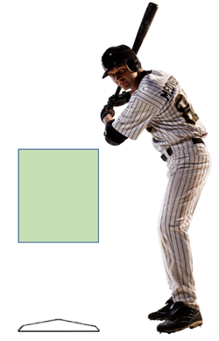
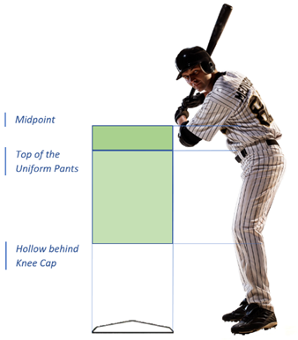

2
1

- The strike zone from about 12U to high school currently is from the hollow behind the knee cap to about the midpoint (between the top of the shoulders and the top of the pants).
- The current college and pro strike zone is the hollow behind the knee and the top of the uniform pants. This is the strike zone that will be used for illustrations.
- Home plate is 17 inches wide (rule 2.02). A baseball is just under 3 inches in diameter (2.94 inches so close enough to just call it 3 inches). The definition of a strike specifies that “any part of the ball passes through (touches) any part of the strike zone”. Therefore, the actual strike zone is 23 inches wide. The black on the edge of the plate is not part of the plate by rule. You can also add approximately 3 inches to the top and bottom of the strike zone for the same fact.
(Source: The Umpires Bible)

12

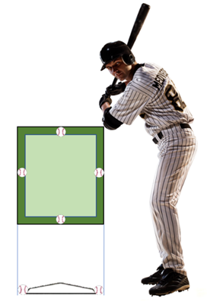
3

Traditional
Batting Tee
Set-up

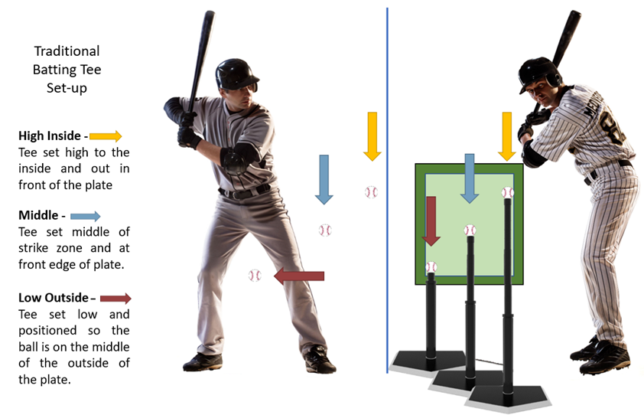

13

But home plate has pentagonal volume. Why is that important? Well, most players only “drill” 3-8 tee positions and since the strike zone has pentagonal volume there is an abundance of locations a ball could cross the plate. Thus, the 3-8 tee positions won’t even begin to address all other potential spots the ball could cross the plate. This also doesn’t take into account all the different pitched ball trajectories coming to one location or speed that influences the swing pattern and timing.

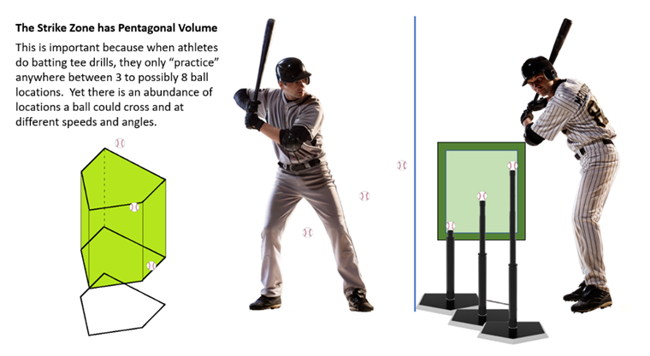
*
* “A pitcher could throw the ball to roughly 80 different points and it be called a strike. If that pitcher threw 4 different types of pitches, that means 320 different lanes to cover.” (Source: baseballthinktank.com). Why so many lanes? Let’s say two pitched balls arrive at the same location BUT at different angles, they have different lanes and speeds. There is no batter in the world that can cover 80 random lanes on every pitch. Let alone a possible 360 or more lanes and be successful. Period. Even the great Ted Williams couldn’t cover the entire strike zone. He was a .250 hitter in one quarter of the strike zone.

14

Consequently, there are countless locations the ball could cross the plate in time and space. Remember, good hitters have good timing and are able to match the angle of the incoming pitch to make solid contact by staying on plane with that pitch as long as possible. Yet using a batting tee, athletes only practice or drill for 3-8 locations and practice only one swing type for those locations even though there are many possible swing patterns for that same location.

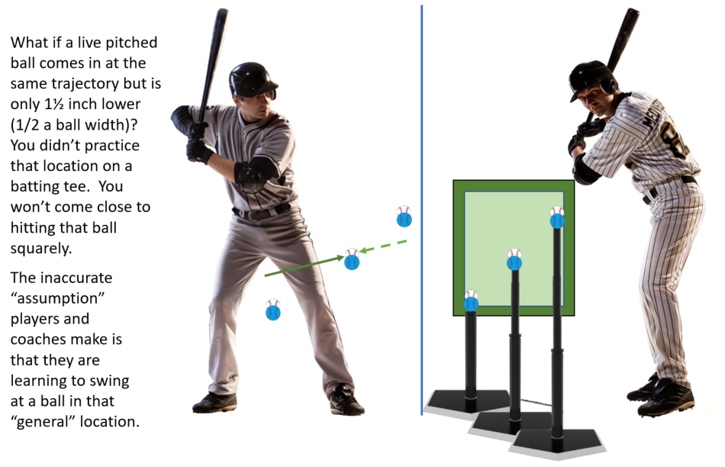

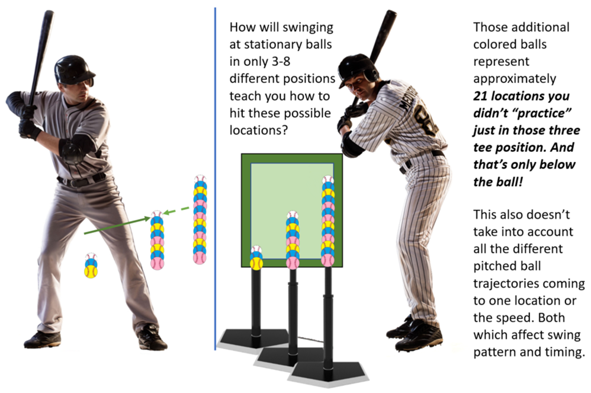

15

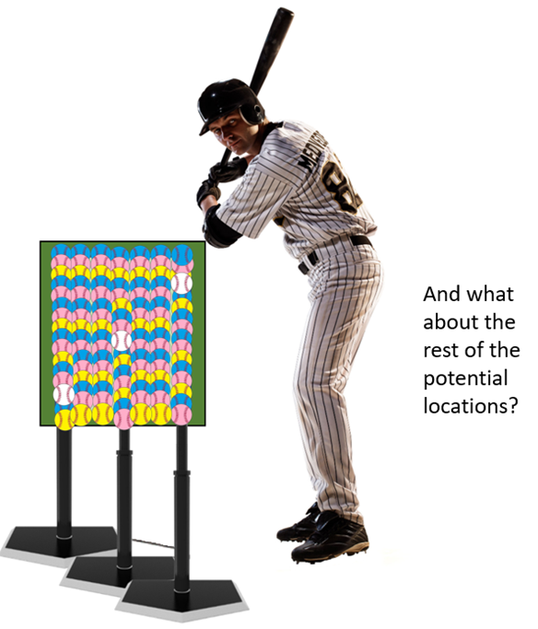

16
A recent study (12) found:
The observed location of impact for intercepting a moving ball is the result of several factors, and therefore, the impact location for a particular flight of a pitch cannot be one specific point in hitting a moving ball. In this sense, impact locations in hitting a moving ball do not actually reflect the mental representation of a batter’s preferred or intended movement.

This means impact locations in hitting a moving ball do not actually reflect the mental representation of a batter’s movement learned or practiced off a batting tee.

BOTTOM LINE:
Location alone doesn't determine the type of pitch nor the type of swing needed. If two pitched balls arrive at the same location BUT at different angles, speed or both, none of the swings can be the same for each pitch to hit the ball square.

The Coaching Contradiction
Section Five

Coaches preach and teach repetition. In practice, a hitting coach will say,

- “Get your swings in.”
- “Get your time in the cage.”
- “Make sure you’re getting your
swings off the tee.”

Most hitting coaches say they want between 50–100 swings a day per hitter. I’ve even heard up to 200. Let’s just look at the 50 swings per day. Even at the low number it shows coaches are training players to swing, swing, swing, swing, swing…times 10!

Using the MLB average, a batter gets up to the plate four times. The average number of pitches a batter sees in the MLB is four. So, they will see approximately 16 pitches at the plate. An MLB batter swings at 46% of pitches. Let’s make it easy and say 50%. So, they swing at eight pitches in the course of a game on average.

To top it off, approximately 30% of those eight swings are balls out of the strike zone.

So, how does taking 50-200 swings off a tee or soft toss for that matter every day “train” a batter to selectively identify and swing at eight quality pitches per game on average?

Spoiler alert - It doesn’t.

17

Now, in the game what do batters hear from their coaches?

- “Get your pitch.”
- “Be patient. Be selective.”
- “Work the pitcher.”
- “Have discipline up there.”

You see, in practice most coaches teach and preach repetition - swing, swing, swing, swing…, but in a game they expect the polar opposite – discipline and patience as well as a good eye.

Hitting coaches have players spend most of their time hitting off a tee, doing soft toss and lobbing in 45-65mph fastballs for hitters to tee off on. Does this really sound like training to hit or just mindless swing repetition? That's not making them a good hitter. It’s just feel good swinging. Big difference. Single minded repetition does not equal learning or transference.

Whole or part practice and Active Movement Training
Section Six
The conventional wisdom or logic taught is that you have to isolate the part of the swing where the “problem” is and then drill or practice the correct skill in isolation. This is identified as “part practice”.

Research(13,14) has shown that to decide if part practice may be beneficial, the task must be analyzed based on the number of segments as well as the degree that those segments are interdependent on one another. If the current portion of a movement is dependent on the movement just completed these tasks are best practiced in their entirety.
“In an instant, the batter must execute a complex combination of perceptual, cognitive and motor skills: determining the type of pitch, anticipating how the ball will move and aiming and timing the swing to arrive at the same place and moment as the ball.” (15)
The decision to practice in part or whole can be based on how complex the motor skill is.
- Complexity: Number of parts or components of a task and the amount of information-processing demands and characterizes a skill;
more complex skills have more
component parts and involve
18

more information processing demands than less complex skills.

There is no argument that swinging a bat to hit a moving ball is a Skill High in Complexity.

The decision to practice in part or whole is also based on the organizational characteristics of the motor skill. Organization, when applied to a complex motor skill looks at the spatial and temporal relationships among the parts of the motor skill.

A motor skill is deemed High in Organization if the spatial and temporal relationships among the parts of the motor skill are interdependent.

There is no argument that swinging a bat to hit a moving ball is a Skill High in Organization: Parts are spatially and temporally interdependent. (Swinging a bat to meet the ball is spatial. When to swing is temporal. Time is crucial and a batter could miss it!).

So, when we analyze the skill this way to determine if we should practice whole or part, we see that swinging a bat to hit a moving ball is a:

- Skill High in Complexity
- Skill High in Organization

Therefore, it is recommended the skill is best practiced whole.

Swinging a bat should be predominately practiced in its entirety. Entirety has to include the characteristics of a moving ball and the movement characteristics of a pitcher. Research shows the more interdependent the movement(s), the more it should be left intact. Swinging a bat to hit a moving ball has interdependent movements.

Hint: Attention focus training for motor skill learning is an approach that involves practicing the entire technique but concentrating on only one aspect of the technique(6). There is a simple way to appropriately teach this method that speeds up learning, transference of skill to automatic unconscious long-term memory (procedural) and retention. Even in novices.

Single-minded repetition is skills practice not transfer practice.
Batting tee falls under the “single-minded repetition of a skill” category. A batting tee is also non-variable “block practice”. By the way, moving the tee to different positions is still non-variable, single-minded repetition. The athlete is still only single mindedly doing one thing just in a different position.

Using a batting tee also continues to reinforce conscious awareness (internal thinking) of a skill (new or known) when
an athlete needs it to be an unconscious

19

action. Interestingly, research shows
that “the learning of new Motor Skills suffers when we direct our attention to the coordination of movements (6).”

Coaches are encouraging conscious control over a process they want to become automatic. The act of “choking” under pressure is widely understood to be a result of the brain trying to regain conscious control over the motor skills in an effort to improve performance. This is the opposite of “being in the zone”. Where an athlete just performs without any conscious effort. But that’s a whole other topic.

Long-term effects of a more variable approach: The Cal Poly Baseball Team Experiment

The following example is from the book “Make it Stick” about the Cal Poly baseball team experiment. “Easier Isn’t Better” (15).

Cal Poly experiment: This was done during practice (real environment - not laboratory).

Going against a live pitcher, one set of batters, Group 1, saw 45 pitches - fastballs, curve balls and change-ups but they were evenly divided up. Group 1 would see 15 curveballs in a row, then 15 fast balls then 15 change-ups.

The other group, Group 2, were given a more difficult practice. The three types of pitches were randomly interspersed across the 45 pitches. For each pitch, the batter had no idea what to expect.

They did this twice a week for six weeks. At the end, the hitting was assessed. Both groups benefited from the “extra” practice but Group 2 (random pitches) in their words –

“displayed remarkedly better hitting relative to those who practiced on one type of pitch thrown over and over.”

The batting tee (and soft toss) is an example of practicing one type of predictable pitch thrown over and over like Group One in the Cal Poly Experiment.

There are a multitude of laboratory and real environmental experiments that support this same result. Coaches and athletes think they are bettering swing mechanics training with a batting tee, but they’re not. Swing mechanics are not produced nor executed in isolation to the environment. Learning and utilizing the appropriate mechanics are dependent on environmental and sensory variables.
20

Hitting live random pitches is transfer practice. It mimics how batter actually plays at the plate. Regardless of what part of the swing an athlete is working on, do it with a different pitch type for every swing. Creating actual playing conditions improves the ability to transfer practice skills from practice to the game.

“…research has shown that the long-term effects of a more variable approach, where multiple things are practiced mixed together, are much more beneficial than single minded repetition and block practice.” (15)

“Ecological psychology, allies to biomechanical analyses of batting and raise some questions about the use of ball projection machines* as a method for acquiring coordination patterns. The ecological constraints of batting against a live ball are very different from batting against a pitching machine, differing especially in the informational constraints that can be used to gear actions, advance information prior to ball release, and vision of a ball's trajectory that are essential for successful performance. A multitude of research suggests practice against real bowlers (pitchers) enables the pickup of constraining perceptual variables rather than non-constraining variables (16)”.

*You can replace the words “ball projection machines” with batting tee or soft toss.

Why Active Movement Training is Important for Optimal Motor Development
Athletes need to be engaged in activities of movement that integrate both movement and perception. Perceptual and motor skills become developed when an athlete can interpret or make sense of the experiences and information together.

Perceptual motor skills are required for performing athletic tasks. It’s any skill involving the interaction and integration of perceptual processes with voluntary physical movement (e.g. to swing or not to swing a bat). Basically, perceptual-motor skill development is a combination of sensory skills and motor skills that allow an athlete to synchronize voluntary physical body movements.

- Perceptual and motor skills involve spatial awareness which is being aware of the space occupied by your body and how to position and maneuver your body in it. Batters need to train to moving objects in order to develop their spatial skills. A recent study(17) showed spatial recognition, such as the ability to shift attention between near and far targets, were associated with fewer strikeouts.
- Perceptual and motor skills have to do with Directional Awareness. Directional Awareness allows the athlete to distinguish between right and left, back and front,
21

bottom and top or down and up. The more honed an athletes Directional Awareness the better they can “read” or identify a pitch early.
- Perceptual and motor skills have to do with Temporal Awareness. Temporal Awareness predicts how soon moving objects arrive.

These skills enhance and develop better reaction time, the ability to pick up visual patterns (from the pitcher and the ball) and hand-eye coordination. These are all very important for successful hitting.

A batting tee also doesn’t train coincidence anticipation. The ability to produce a response that accurately coincides with the arrival of a moving stimulus. For example, being able to hit a moving ball accurately with a baseball bat.

All are developed training with live pitching.

None are developed training with a batting tee.

Batting Tee will teach you to hit a ball with backspin – MYTH
Section Seven
A batter has limited control hitting a ball with backspin. When the bat makes contact with a ball, the ball obviously goes in the reverse direction toward the field. But the reverse direction also changes the ball's spin.

Mont Hubbard and colleagues at the University of California, Davis modeled all the forces on a batted ball and found:

- A fastball arrives at the plate with backspin. Once hit, it leaves with topspin.
- A curveball arrives at the plate with topspin. Once hit, it leaves with backspin.

In with back spin

In with top spin
Whether you’re a high school, college or pro baseball player there is no way a batter can control hitting a baseball with backspin constantly or predictability. Don’t worry or waste your time trying to do it. Not to say back spin won’t help with distance - just that backspin is pretty much out of a batter’s hands. A batter’s focus needs to be on hitting the ball square, not cutting the ball or trying to hit just below center line to create backspin. At best, you can create a “knuckle ball” as the ball leaves the bat.

The fact is, back spin is influenced by several factors. Here are just four. First is pitch location. Then the bats Vertical Bat Angle (VBA), Horizonal Bat Angel (HBA) and “Attack” Angle (AA). We cover the scientific and real life proof that back spin is created by much more than just having a positive upward swing path. Details can be found in the Baseball Education Center at https://www.thebaseballobserver.com.

22

Out with top spin

Out with back spin

23
I’ve heard it a thousand times: “Watch the ball hit the bat”. Then there’s “…training to look for a specific part of the ball to hit over and over and over.” Or as one tee manufacturer states “Just keep your eye on the ball, and let our baseball hitting tee do the rest.”

- From Yale professor, Dr. Robert Adair and former physicist to the Nation League: “You might as well close your eyes. All the information you have to hit the ball is in your brain when the ball is at the halfway point to the plate.” From The Language of Sport by Tim Considine.
- Ken Fluid, visual psychophysicist: “In the last several feet before the plate, the ball reaches an angular velocity that exceeds the ability of the eye to track the ball. The BEST hitters (pro’s) can only track the ball to within 5-6 feet of the plate.” From “Busting Baseball Myths.
- “To hit the ball the batter must predict when and where it will cross the plate” From Biomechanical Principles in Sports (2004).
- “Batting is a matter of generating bat speed and guessing where the ball will be.” From physicist Peter Brancazio, author of Sports Science.

Here is a more recent scientific study that substantiates the fact. PLOS ONE Journal: Feb 2016 – Takatoshi Higuchi et. al. “Contributions of Visual Information about ball trajectory to baseball hitting accuracy.”

The study tested college baseball players vs. pitching machine throwing random fastballs and change-ups.

Group 1- The vision for each batter was obscured early (using glasses that could be electronically altered) from ball release and the first 15 feet. After 15 feet, the batter’s vison was cleared to see the rest of the pitch. Group 1’s ball contact for both pitch types were terrible.

Group 2 – The vision for each batter was clear from delivery up until the last 15 feet, so their vison was obscured late.

Group 3 – The vison for each batter was never obscured. They saw the entire ball path. Group 2 & 3’s contact for both pitch types were almost identical. It didn’t matter that group 2 couldn’t see the bat hit the ball. They still hit just as well as Group 3 and much better than Group 1 who had the chance to see bat-ball contact if they could. See contact results chart on next page.
Watch the ball hit the bat - MYTH
Section Eight

Contact Results Chart
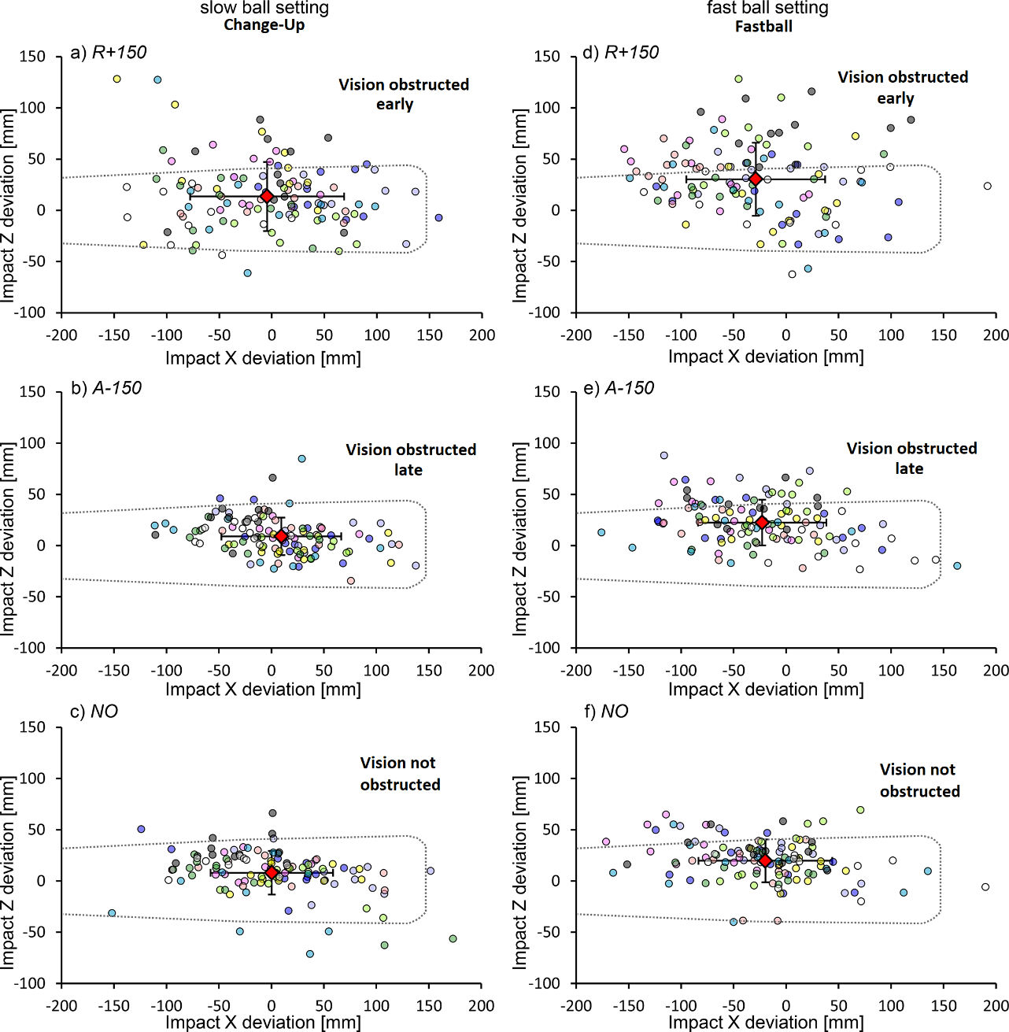

GROUP 1

GROUP 2

GROUP 3

24
Simply put, it’s a biological impossibility. When the human eyes see an object, it takes one-tenth of a second for the brain to process that information. Therefore, the information the brain receives from the eye is already out of date. More so if that object is moving fast toward them like a baseball. Secondly, “To keep the ball in view after the pitcher first lets it go, the batter's eyes must cover a visual field of only about 15°. But when the ball reaches a point about 20 feet from home plate the batter must be able to see over a much greater angle. The ball's relative speed to the batter has increased to the point where even the slow ball travels too fast for the eyes to keep up with it over this wider field (18).”

You can’t see the ball hit the bat and has been scientifically shown it doesn’t matter even if you could. Why waste time practicing for something you can’t do? But it’s obviously very important to see it early. So maybe that’s something batters should work more on instead….

Álex Rodríguez
While there are many visual examples, here we are only going to show two using professional baseball players. This is just the simple and brief explanations.
NOTE: Live pitched ball locations and tee locations have been matched to almost the same locations. So, for example we are not comparing an inside live pitch to a batting tee outside pitch.
Comparing Apples to Oranges - Visual Evidence
Section Nine
First, this screen shot is right before he loads, lifting his foot off the ground. The green line above his head indicates horizonal head positioning.

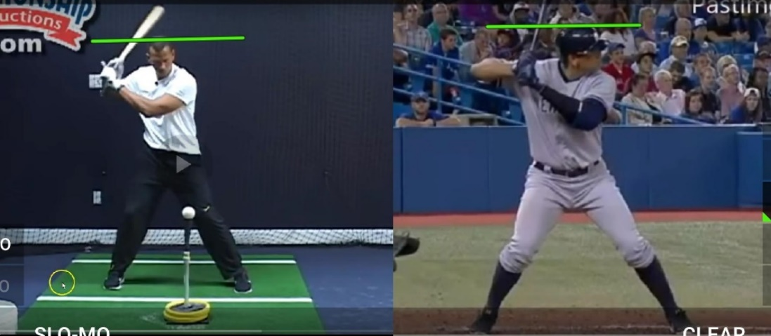

Next is right before he strides forward. Notice on the batting tee he is much further back and knee above back foot (weak). He has dropped below the green line. He has also pulled his arms much further back. Live pitch, he is loaded but more centered. The knee is lined up just inside the back foot (strong). Head is still level with green line.

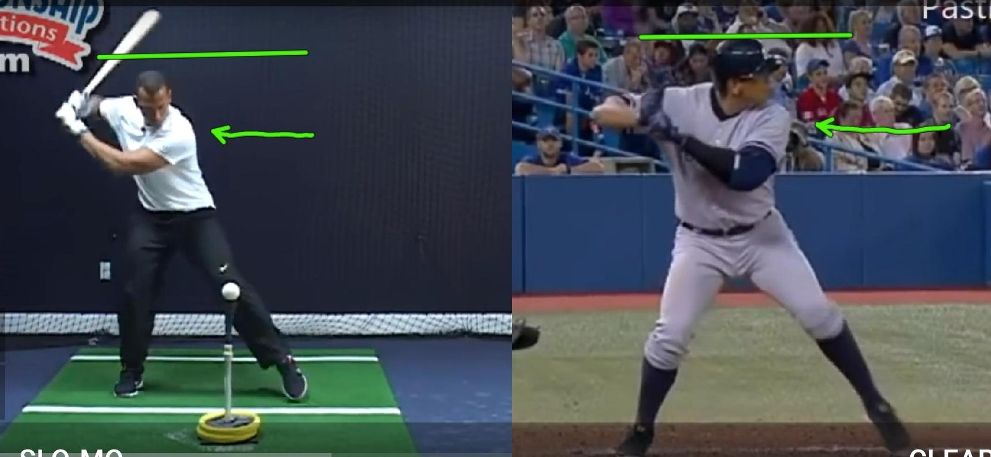

25

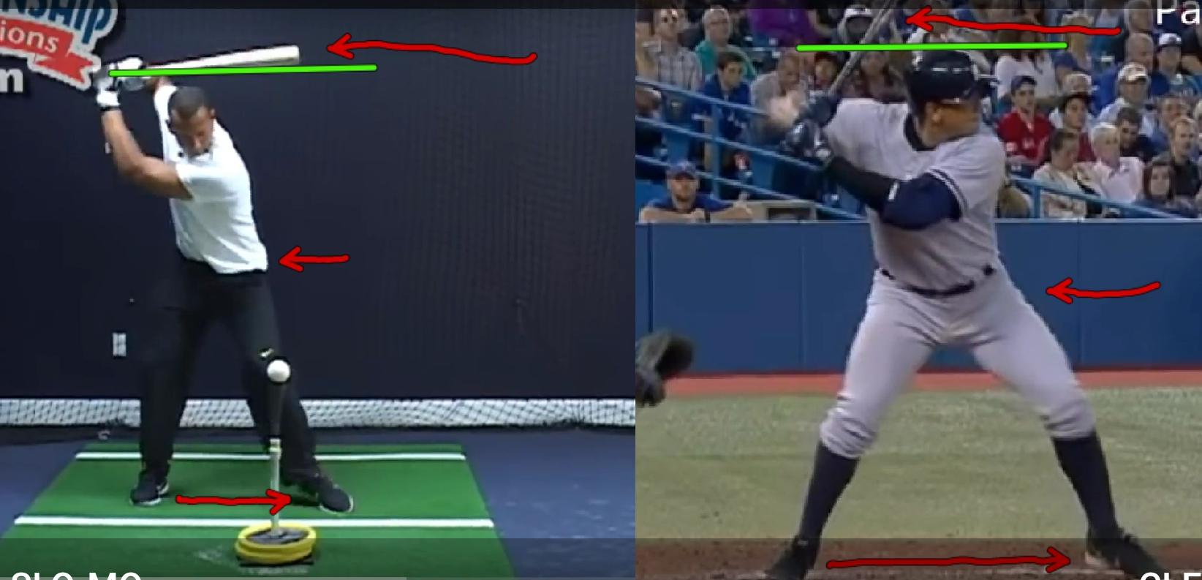
A split second before heal plant there are very noticeable differences. Here are just a couple. Batting tee: Huge bat wrap, hips are not in-line with “pitcher”. They have twisted. You don’t twist your hips; you slightly rotate at your waist – keeping your hips square with the pitcher. This engages your abs and creates the “stretch-shortening” cycle allowing you abdominals to help create good torque (rotational force and the release of elastic energy) and efficiently transfers the force generated from the lower body (legs & glutes) up the kinetic chain. Shorter stride.

In the live pitch, he is still hasn’t moved his head from horizonal, hips are in-line with the pitcher and a little rotation at the core for the stretch-shortening cycle. No bat wrap. Top of the bat in-line with the middle of the helmet.

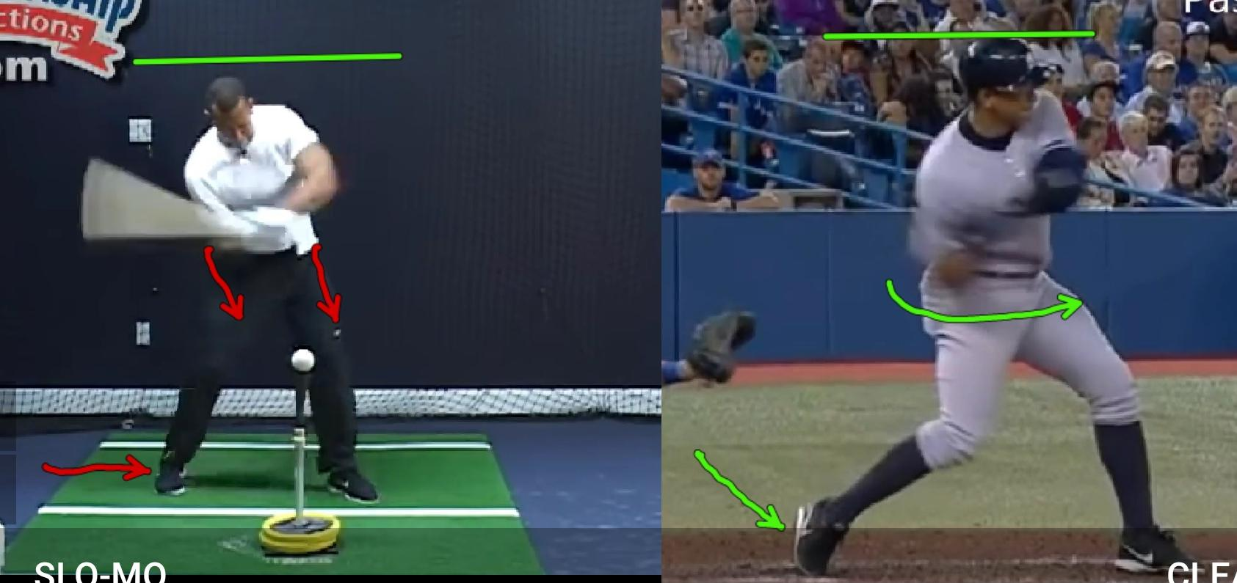
Batting tee: Hips are lagging, they are square with the batting tee therefore, body is lagging. This induces using the hands to throw the bat at the ball creating a more downward angle of approach and disrupts the kinetic chain greatly limiting the energy transfer from the lower body so the swing becomes dependent on the weaker upper body. Back foot still hasn’t rotated. Ball of the back foot planted firmly in the ground.

Live pitch: Head still hasn’t moved. Hips are now rotating and back foot releasing from the ground. Good energy transfer continues up the kinetic chain.

26

At contact. Batting tee. Back foot now “squashing the bug”. It’s acting like an anchor not allowing the hips (still lagging) to fully release. This substantially reduces any rotational force (torque) for power. You can see his upper body also lagging forcing the weaker arms to try to compensate.

Live pitch. Head still in place, back foot completely released allowing the hips to rotate freely. Hips, body and shoulders square with pitcher keeping the kinetic chain intact.
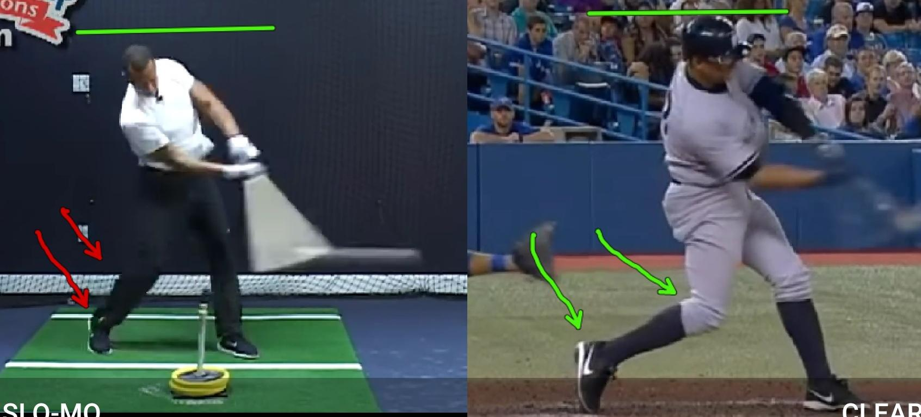

Batting tee. Still lagging rotation. Back foot still acting as an anchor holding hips back from rotating because “squashing the bug”. Therefore, slowing rotation.

Live pitch. Back foot released allowing hips and upper body to continue to rotate. Look how much more rotated he is in this picture vs. the batting tee.

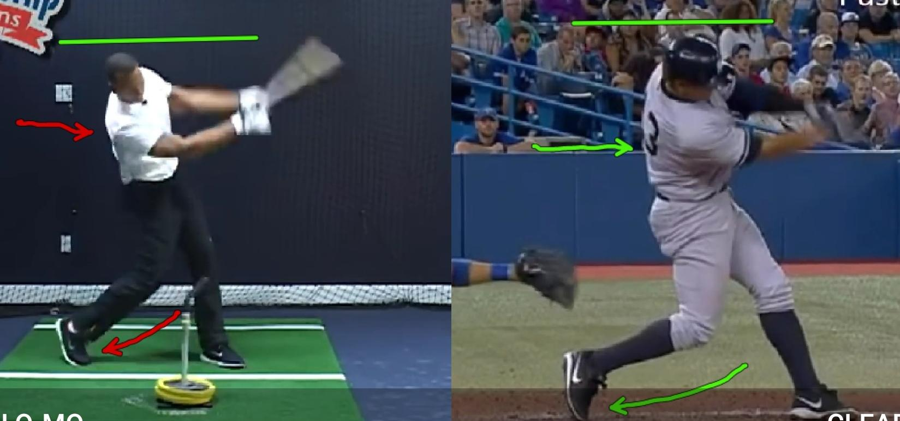

27

Finish. Batting tee. Upper body never fully rotated. Live pitch. Body fully rotated (see numbers on back).

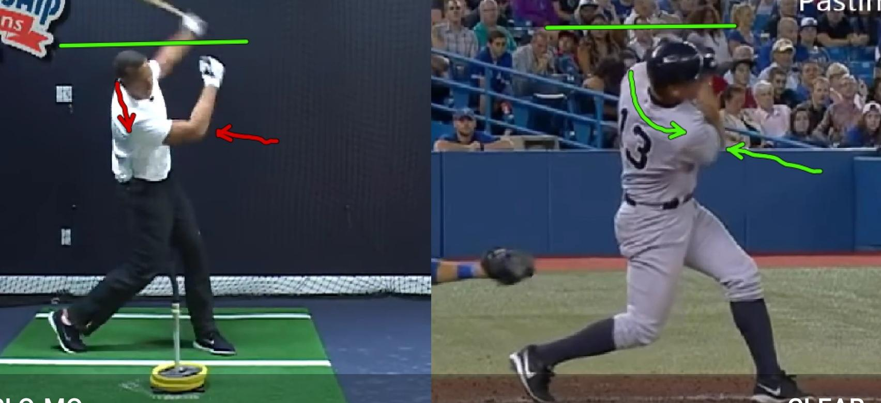

Remember, this isn’t a full breakdown. It was to show a few of the discrepancies between “tee work” and live pitching. I have several years of videos of players I have trained or seen hitting off a tee, then footage of them hitting in real games and comparing them side-by-side. That’s when I noticed the differences first myself. It isn’t just this one moment in time. I’ve seen the consistent difference between the two for 10+ years.
Chris Taylor

First, this screen shot is right at front foot heal plant. The green line above his head indicates horizonal head positioning.

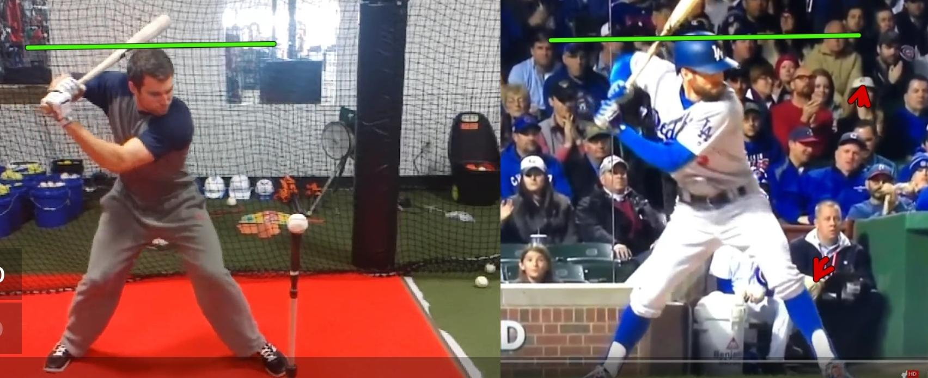

28

Batting tee. Has begun to raise up (head coming above horizonal). Leading the swing with his hands - throwing his hands at the ball. Bypassing stretch-shortening cycle and breaking up the kinetic chain. See how far in front of his body his arms and hands are? This creates a downward swing to the ball (chopping at it). Live pitch. Head still even with horizonal line. Arms tight with body. Not leading with hands which allows the kinetic chain (rotation) to stay intact and create power. Bat getting on path with the trajectory of the ball as soon as possible.

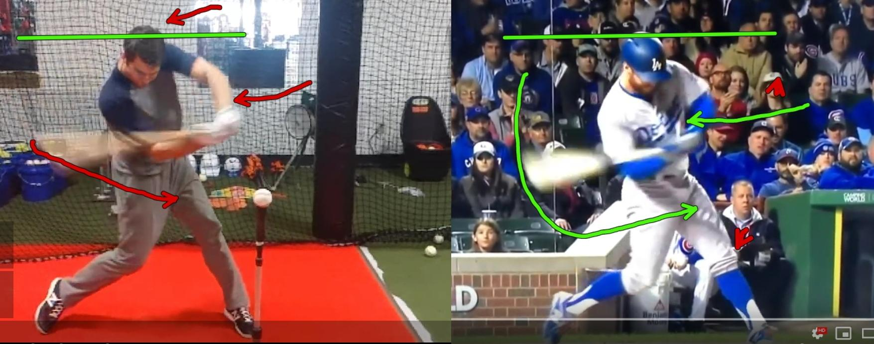

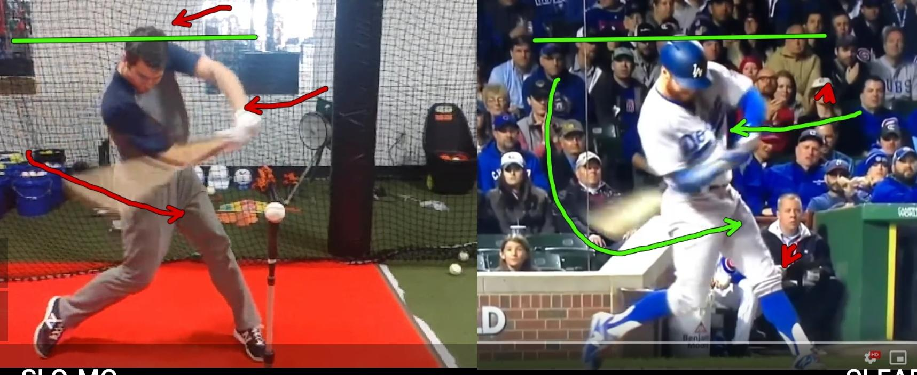

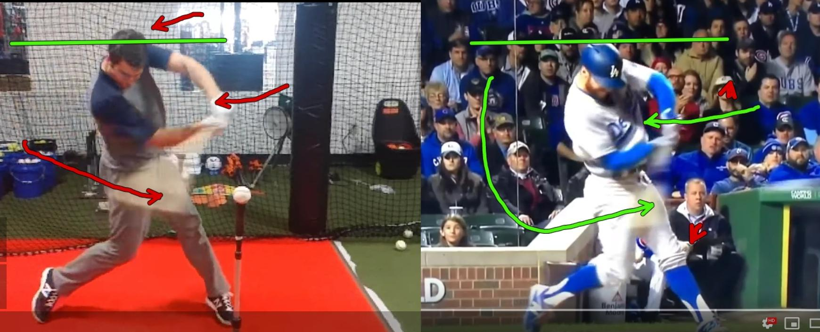

29

At contact. Batting tee. Elbow away from body (weak position). Raising up a bit more at contact which takes away from the energy of the swing. Head of the bat is also angled down more. Live pitch. Elbow close to body (strong position). Head still hasn’t moved from horizonal which keeps energy focused for the swing. No head movement also allows for visual stabilization. Visually the ball doesn’t “jump around”. Head of the bat not as angled as the batting tee. Notice the ball launch angle (see blurry ball). Almost flat off tee. Better angle off live pitch. Reason? Indicates this is probably his preferred attack angle when there is no moving ball to read.

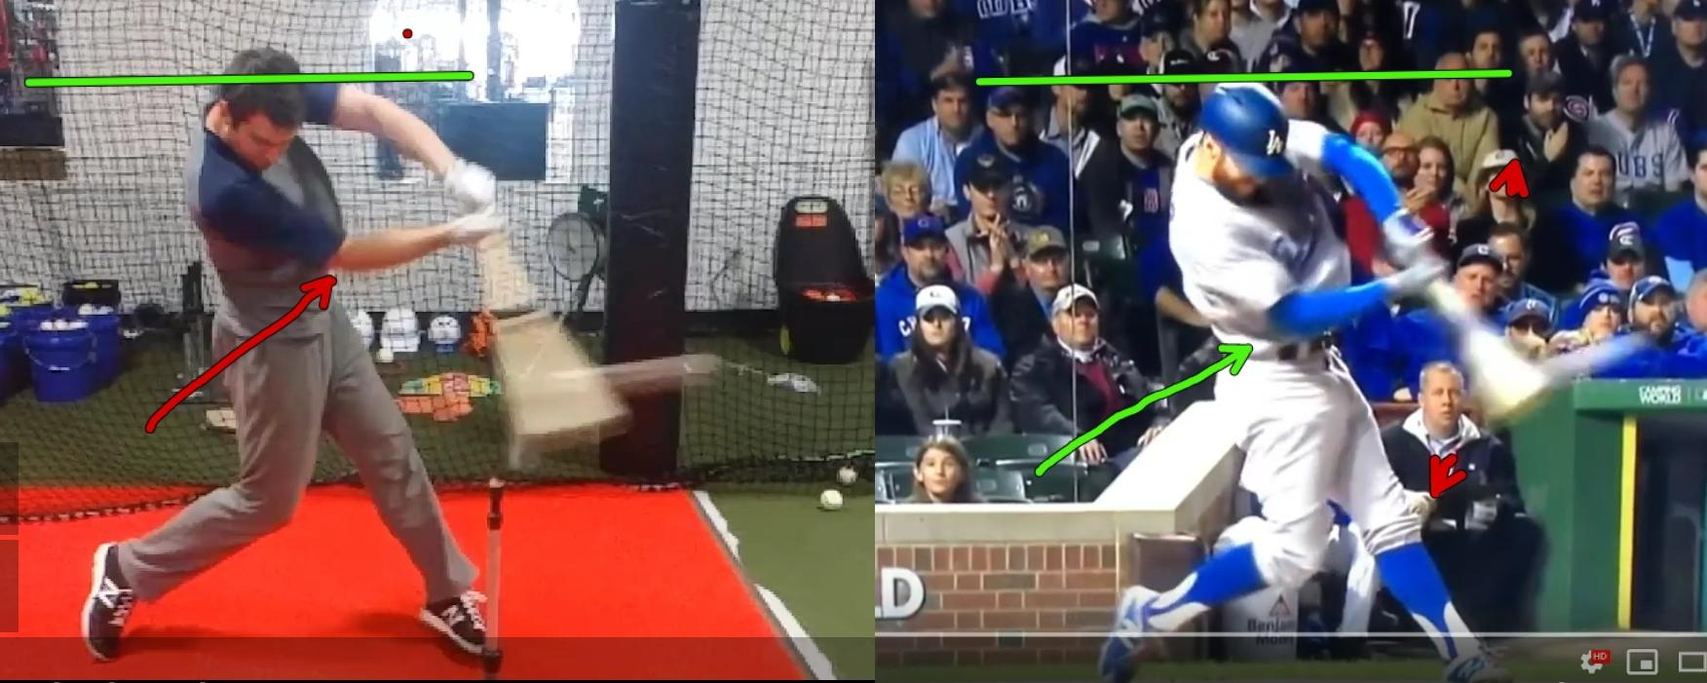

Fairly similar follow through with a couple difference. Batting tee. Head has risen a bit higher. Notice back knee isn’t as bent so the muscles there are more tense (obviously from lifting up). Therefore, there were weaker forces going to the swing because some of that energy had to be used to raise up. Live pitch. Head actually came down a bit. Back knee is more relaxed and bent forward allowing the hips to rotate with less restriction and efficient transfer of power through the kinetic chain optimizing swing speed.

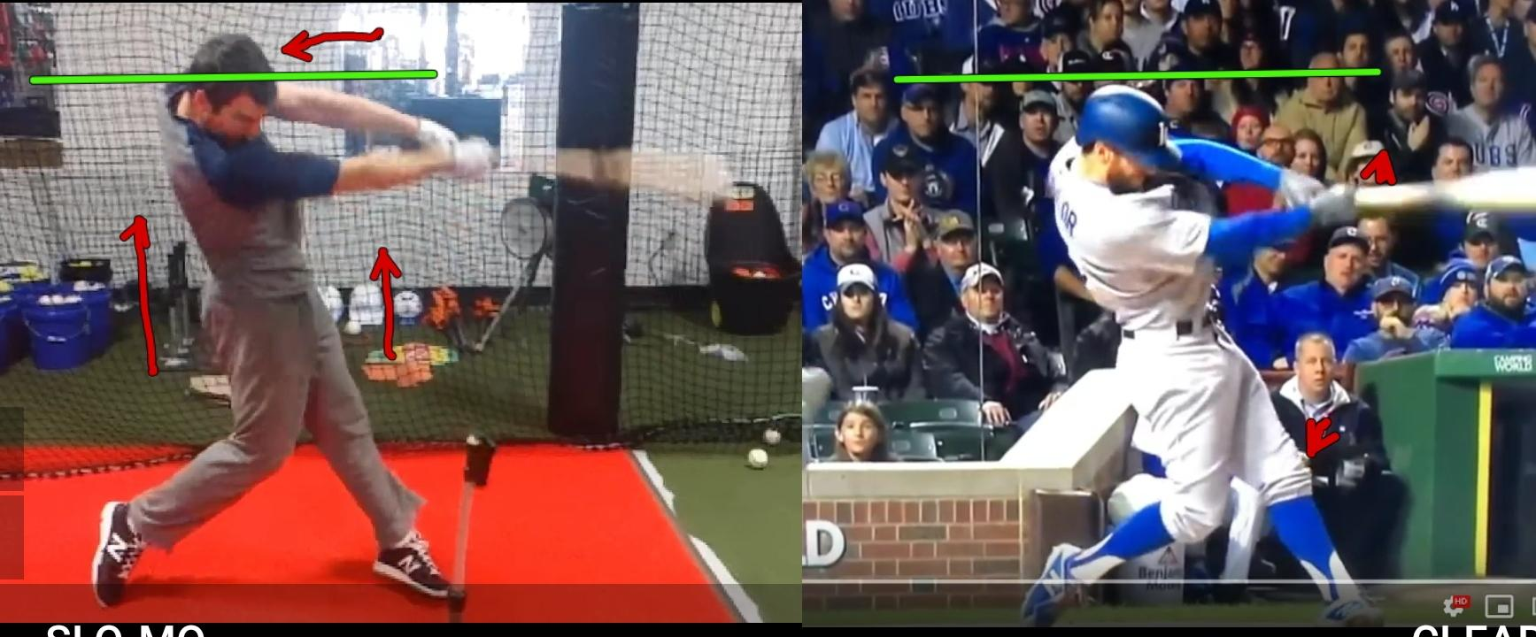

30

It’s Impossible to Work Both Timing and Mechanics Learning a New
Motor Skill- MYTH
Section Ten

Below is a statement in an email I received from a batting coach with a prominent website. What he wrote shows “old school thought” because “it’s the way it’s always been done.” The status quo. Here is just one thing he wrote:

“Working timing and mechanics with a moving ball is dang near impossible, especially when learning new motor skills.”

I humbly disagree because all the years of unbiased independent research shows you can and should. So, don’t just take my almost 30 years of personal coaching experience saying you can. Over many years, I have worked with countless athletes. And on the rare occasion if I do use a batting tee, it’s only once or twice for no more than approximately 8-10 swings. All the rest of our sessions are with live pitching (wiffle balls and baseballs) and other methods that do not direct conscious attention to mechanics.

“According to traditional views, people have to go through a learning stage in which they consciously control their movements. But it’s been proven that conscious control is detrimental. As it turns out, there does not appear to be much support for the view that a “skilled
focus” (at least one that directs attention directed to the execution of
31

the movement) is very effective – even in the early stages of learning (6).”

There are ways to learn new skills without directing conscious attention to the coordination of body movements in isolation and athletes all respond better, quicker and retain more vs. using a batting tee.

I have found neither age, experience nor seemingly “difficult” training hampers learning – if understood how to implement by the trainer. A batter’s mechanics are dependent on quickly identifying the type of pitch thrown and other environmental variables in coordination with their motor skill initiation and movement.

A batting tee is easy. I get that. It’s one of the few hitting training aids that a player can do on their own, in a confined space, convenient and a batter can get as many reps in as they want. Hitters work off the tee regularly because they’ve been told or just personally believe it keeps their mechanics clean and crisp.

the movement) is very effective – even in the early stages of learning (6).”

There are ways to learn new skills without directing conscious attention to the coordination of body movements in isolation and athletes all respond better, quicker and retain more vs. using a batting tee.

I have found neither age, experience nor seemingly “difficult” training hampers learning – if understood how to implement by the trainer. A batter’s mechanics are dependent on the type of pitch thrown and other variables (see definition of dynamic interceptive motor skills & open skilled sport).
Batting tee – one variable and conscious control of body movements done in isolation, ignoring the other variables that actually dictate the technique and execution of the skill being learned.
Summary

“Do what is right, not what is easy nor what is popular.”
- Roy T. Bennett

They follow the status quo:

“… a tee provides more than any other drill is consistency. While the ball sits in an idle position, the player has the ability to take their time in setting themselves up and control their timing and approach. Variables are eliminated. Mechanics can be exaggerated allowing for muscle memory to take over. A consistent stance and approach leads to the player obtaining a comfort level which in turn will translate to success.”
(Quote taken from a franchised baseball/ softball training facility website. Quote used only as a reference and in no way implies poor instruction on their part)

Matt Helke AIC, CSPC, CSH, CCS, BMS - has a BS in Psychology (perception & cognition) from Wright State University 1988. Matt is a Performance Optimization Mentor and has been an active baseball coach since 1992. He is an Accredited Interscholastic Coach, with certifications in: Sports Psychology Coach (Ed.), Sports Hypnosis & Visual Guided Imagery, Core Conditioning Specialist, a Biomechanics Specialist and training in Applied Neuroscience & Brain Health. Founder of The Baseball Observer Digital Magazine and 360 Peak Performance. He is a member of the NFHS, ABCA, OHSBCA and a Professional Affiliate of APA Div. 47 (Society for Sport, Exercise and Performance Psychology). Matt has worked with numerous players, coaches, parents and teams over the past 25yrs. to help them advance to the next level. Contact: coachhelke@yahoo.com

APA Div. 47 (Society for Sport, Exercise and Performance Psychology). Matt has worked with numerous players, coaches, parents and teams over the past 25+yrs. to help them advance to the next level.

Coach Helke works with individual athletes, coaches, teams and organizations.
For more information contact: coachhelke@yahoo.com
www.thebaseballobserver.com

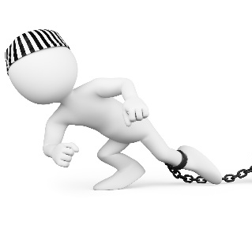
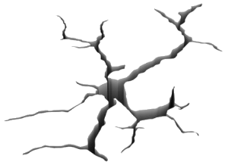

Research references and graphics credits on following pages

32
©2020 The Baseball Observer & 360 Peak Performance. All rights reserved.

This article isn’t about saying everyone who trains with a batting tee is wrong - but to present knowledge and facts most aren’t aware even exist. For someone to possibly pause for a moment and think when they now read or hear any statement similar to the status quo. That was intentional because remember:

“Every day we must question what we think we know. Many times, being exposed to just one new idea reveals there are more things to learn.”

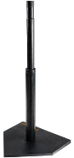

(1) Caine RN, Caine G. Making Connections: Teaching and the Human Brain. Menlo Park, CA: Addison-Wesley; 1994.
(2) Jensen E. Teaching with the Brain in Mind. Alexandria, VA: Association for Supervision and Curriculum Development; 1998
(3) Prigge D. Promote brain-based teaching and learning. Intervent School Clinic. 2002; 37:237–241.
(4) David Wm. Yeager, A. C. (n.d.). Hitting – A Matter of Perception. How eye dominance and visual recognition influence hitting success.
(5) Greenwood, Daniel & Davids, Keith & Renshaw, Ian. (2013). Experiential knowledge of expert coaches can help identify informal constraints on performance of dynamic interceptive actions. Journal of sports sciences. 32. 10.1080/02640414.2013.824599.
(6) Wulf, Gabrielle. Attention and Motor Skill Learning. Champaign, IL: Human Kinetics 2007.
(7) Galligan, F. et al. (2000) Acquiring Skill In: Advanced PE for Edexcel. 1st ed. Bath: Bath Press, p. 102-108
(8) Land MF, McLeod P. From eye movements to actions: how batsmen hit the ball. Nat Neurosci. 2000 Dec; 3(12):1340-5.
(9) Regan D (1997) Visual factors in hitting and catching. Journal of Sports Sciences 15: 533–558.
(10) Bahill AT, LaRitz T (1984) Why can’t batters keep their eyes on the ball? American Scientist 72: 249–253.
(11) Ian Renshaw, Anthony R.H. Oldham, Keith Davids & Tim Golds (2007) Changing ecological constraints of practice alters coordination of dynamic interceptive actions, European Journal of Sport Science, 7:3, 157-167, DOI: 10.1080/17461390701643026
(12) Katsumata, H., Himi, K., Ino, T., Ogawa, K., & Matsumoto, T. (2017). Coordination of hitting movement revealed in baseball tee-batting. Journal of Sports Sciences, 35(24), 2468–2480. doi:10.1080/02640414.2016.1275749
(13) Schmidt RA, Lee TD. Motor control and learning: A behavioral emphasis. Human Kinetics Publishers; 2005
(14) Muratori LM, Lamberg EM, Quinn L, Duff SV. Applying principles of motor learning and control to upper extremity rehabilitation. J Hand Ther. 2013; 26(2):94-102; quiz 103.
(15) Brown, Peter, Roediger, Henry III, McDaniel, Mark. Make it Stick. The Belknap Press of Harvard University; 2014 pgs. 79-82
(16) Portus, M. R., & Farrow, D. (2011). Enhancing cricket batting skill: implications for biomechanics and skill acquisition research and practice. Sports Biomechanics, 10(4), 294–305. doi:10.1080/14763141.2011.629674
(17) Burris, Kyle, et. al. (2018) "Vision, sensory and motor testing could predict best batters in baseball: High scorers on computer tests spent more time on base, had more walks, fewer strikeouts." Duke University Medical Center, ScienceDaily. ScienceDaily, 8 January 2018.
(18) https://vault.si.com/vault/1954/09/13/you-cant-keep-your-eye-on-the-ball
References
33

Images/ Photos/ Graphics
Copyright: Silhouette of a baseball player batter on dart black background from particles, dust, smoke - www.123rf.com/profile_tnn103eda

Open Source: Matrix screen

Copyright: Lemmings off a cliff - Sarah Carol

Copyright: 3d render of person pointing to chalkboard with text facts and crossed myths - www.123rf.com/profile_nasirkhan

Copyright: 3d render of people speaking loudly to frustrated man using megaphones - www.123rf.com/profile_nasirkhan

Copyright: Isolated on white professional baseball player in action - www.123rf.com/profile_tnn103eda

Copyright: Isolated on white professional baseball players in action - www.123rf.com/profile_tnn103eda

Copyright: 3d rendering of man having headache during fight on disputed problem - www.123rf.com/profile_nasirkhan

Copyright: 3d rendering of business person presentation of case study word - www.123rf.com/profile_nasirkhan

Copyright: 3d questions words boxes on white background - www.123rf.com/profile_nasirkhan

Open Source: Contact Chart: PLOS ONE Journal: Feb 2016 – Takatoshi Higuchi et. al. “Contributions of Visual Information about ball trajectory to baseball hitting accuracy.

Youtube Screen Shots:
Álex Rodríguez batting tee – https://www.youtube.com/watch?v=wVWnPonuLsg

YouTube Screen Shots:
Álex Rodríguez game swing - https://www.youtube.com/watch?v=eMTpFEJC1dc

Youtube Screen Shots:
Chris Taylor batting tee - https://www.youtube.com/watch?v=ztt5a0bLtys

Youtube Screen Shots:
Chris Taylor game swing - https://www.youtube.com/watch?v=wEteGuLxC3o

Copyright: 3d illustration of cracked ground earth - www.123rf.com/profile_asfia

Copyright: Man with chain on ankle - www.123rf.com/profile_texelart
34

